Air Quality Intelligence: India Air Pollution Monitoring, Operational and Risk Analysis
India's air quality crisis has become one of the most pressing public-health and policy challenges of the decade, with hundreds of Central and State Pollution Control Board (CPCB/SPCB) monitoring stations continuously recording pollutant concentrations across cities and states. As monitoring infrastructure has expanded, the volume of real-time air-quality, meteorological and location data generated has grown enormously. Despite this abundance of data, converting raw station-level readings into clear, actionable intelligence for regulators, city administrators and citizens remains a significant challenge. This calls for a structured analytical pipeline that can move data from raw collection through to decision-ready insight.
Through this analysis, the project surfaces critical insights such as the cities and stations with the most severe pollution readings, the seasonal and hourly rhythm of AQI levels, the pollutants that most influence overall air quality, and the meteorological conditions (wind speed, humidity, temperature) associated with the worst readings. These findings support three groups of stakeholders — data analysts, pollution-control policy teams and public-health researchers — in prioritizing monitoring resources, issuing advisories, and targeting interventions where they will have the greatest impact.

Scenario 1: Ananya Rao — Environmental Data Analyst
Ananya Rao, a Data Analyst at a state pollution-control research unit, analyzes station-level AQI trends, pollutant composition and seasonal variation using SQL queries and Power BI dashboards. She identifies the highest-AQI cities and stations by studying metrics such as Average AQI, Max AQI and pollutant-level averages, and uses the Decomposition Tree to drill from national figures down to the specific city or station driving a spike. Her analysis helps monitoring teams prioritize which stations need calibration checks or additional sensors, and gives regulators an evidence base for where pollution control measures are most urgently needed.

Scenario 2: Karan Mehta — Urban Policy & Compliance Officer
Karan Mehta, a Compliance Officer at an urban pollution-control board, is responsible for translating AQI readings into policy action — issuing health advisories, triggering graded response action plans, and tracking compliance against national ambient air-quality standards. He monitors the AQI_Bucket distribution (Good through Hazardous) and the count of high-AQI readings across cities and seasons to decide when to escalate restrictions on construction, vehicular movement or industrial activity. Seasonal and state-level AQI comparisons help him time interventions ahead of the periods when pollution is expected to peak.

Scenario 3: Divya Nair — Public Health Researcher
Divya Nair, a Public Health Researcher at a health-advisory organization, studies the relationship between pollutant exposure and population risk. She tracks pollutant-specific averages (PM10, PM2.5, NO2, SO2, CO, OZONE, NH3) alongside meteorological drivers such as wind speed and humidity to understand which conditions produce the most hazardous readings. Her work translates dashboard-level pollutant and AQI-bucket insights into public health advisories, helping vulnerable groups know when and where exposure risk is highest.

Technical Architecture
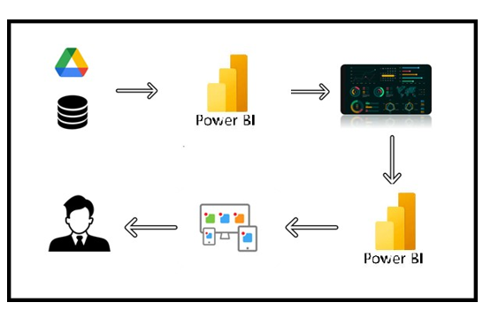

Project Flow
To accomplish this project, the following milestones and activities are completed end-to-end:

Project Flow
To accomplish this project, we have to complete all the activities listed below:
1. Problem Definition & Data Collection

Identify the business problem

Define project objectives

Collect the dataset

Understand dataset structure

2. Database Setup & SQL Analysis

Create SQL database

Store dataset in the database

Perform SQL operations

3. Power BI Data Preparation

Connect SQL database with Power BI

Clean data using Power Query

4. Data Analysis & AI-Assisted Insights

Create KPIs and DAX measures &Explore factors affecting employee attrition

Use Decomposition Tree

Use Key Influencers

5. Data Visualization & Dashboard Development

Create visualizations minimum 8 -12 visuals( prefer using QnA)

Use Power BI Q&A for business questions

Visualize employee attrition patterns

Design dashboard with insights

6. Report Development

Report 1

Report 2

7. Performance Testing

Amount of data rendered to the database

Utilization of data filters

number of calculation fields

number of visualizations/graphs
8. Project Demonstration & Documentation
- Record explanation video for project end-to-end solution
- Project Documentation – Step-by-step project development procedure

Milestone 1: Problem Definition & Data Collection
In this milestone, learners want to understand the business problem and identify the data required for analysis. Learners will translate business requirements into analytical questions, identify relevant data sources, collect appropriate datasets, and assess their quality and relevance. This milestone provides a strong foundation for accurate and meaningful data analysis.

Activity 1 : Identify the Business Problem
Air pollution in India varies dramatically by city, season and time of day, but this variation is difficult for regulators, city administrators and citizens to see clearly without a consolidated, queryable view. Monitoring stations across the country generate a continuous stream of pollutant readings, yet without a structured analytical layer, this data remains too fragmented to drive timely decisions such as issuing health advisories, allocating monitoring resources, or triggering pollution-control action plans.

Activity 2 : Define Project Objectives
● Consolidate station-level AQI and pollutant readings from across India into a single, queryable structure.
● Identify the cities, states and stations with the most severe (highest) AQI readings.
● Understand how AQI varies by season, month, day-of-week and hour of day.
● Determine which pollutants and meteorological conditions most strongly influence overall AQI.
● Deliver an interactive dashboard and reports that support monitoring, policy and public-health decisions.

Activity 3 : Collect the Dataset
The Enriched AQI dataset is a comprehensive collection of real-time air-quality readings gathered from CPCB and State Pollution Control Board monitoring stations across India, enriched with meteorological context and derived time attributes. The dataset represents a detailed, station-level cross-section of India's air-quality network, capturing pollutant concentrations, computed AQI values and severity buckets, geographic metadata, and weather conditions at the time of each reading, enabling in-depth analysis of pollution severity, seasonality and geographic distribution.
Dataset Link :Dataset

Activity 4 : Understand the Dataset Structure
The dataset contains 10,521 records across 22 fields. Each field is described below:
- country: Country in which the monitoring station is located (India). Scopes the dataset to the Indian national air-quality monitoring network.
- state: Indian state in which the station operates. Enables state-wise pollution comparison and supports state pollution control board (SPCB) reporting.
- city: City where the monitoring station is situated. Core dimension used to rank cities by pollution severity.
- station: Specific CPCB/SPCB monitoring station name and operating agency. Provides granular, site-level readings for hotspot identification.
- last_update: Timestamp of the most recent reading captured at the station. Source field used to derive Year, Month, Day, Hour and Day_of_Week.
- latitude / longitude: Geographic coordinates of the station. Support map-based and geo-spatial analysis of pollution spread.
- pollutant_id: The specific pollutant measured at the station (PM2.5, PM10, NO2, SO2, CO, OZONE, NH3). Central dimension for pollutant-level comparison.
- pollutant_min / pollutant_max / pollutant_avg: Minimum, maximum and average concentration recorded for the pollutant during the reporting window; the basis on which AQI is derived.
- AQI: The computed Air Quality Index value for the reading. The primary metric used across every KPI, chart and AI insight in this project.
- AQI_Bucket: Categorical severity classification: Good, Moderate, Unhealthy for Sensitive Groups, Unhealthy, Very Unhealthy or Hazardous. Used for risk segmentation and public communication.
- Temperature_C: Ambient temperature in Celsius at the time of the reading. A key meteorological driver of pollutant dispersion.
- Humidity_%: Relative humidity percentage. Influences particulate behaviour and measured AQI.
- Wind_Speed_kmh: Wind speed in km/h. Affects how quickly pollutants disperse or accumulate near a station.
- Year / Month / Day / Hour: Date and time components derived from last_update. Enable trend, seasonality and time-of-day analysis of pollution levels.
- Day_of_Week: Numeric day-of-week indicator. Supports weekday-versus-weekend pollution pattern analysis.
- Season: Meteorological season (Summer, Winter, Spring, Autumn) derived from the reading date. Enables seasonal comparison of air quality.

Milestone 2: Database Setup & SQL Analysis
In this milestone, learners work with the setting up databases and developing the SQL skills needed to work with structured data. Learners will create and manage database objects, load and organize data, and write SQL queries to retrieve, filter, transform, and analyze information. The milestone builds a strong foundation for efficient data analysis and prepares learners to work with real-world datasets and business problems.

Activity 1 : Create SQL Database and Load the Dataset
A SQL database (AirQualityDB) was created to store the enriched AQI dataset in a structured relational format. The enriched_aqi.csv file was imported into a single aqi_readings table, preserving all 10,521 records without truncation. Appropriate data types were assigned to the 22 fields, including text fields for country, state, city, station, and pollutant_id; numeric fields for pollutant measurements, AQI, temperature, humidity, and wind speed; and date/time fields for last_update columns.
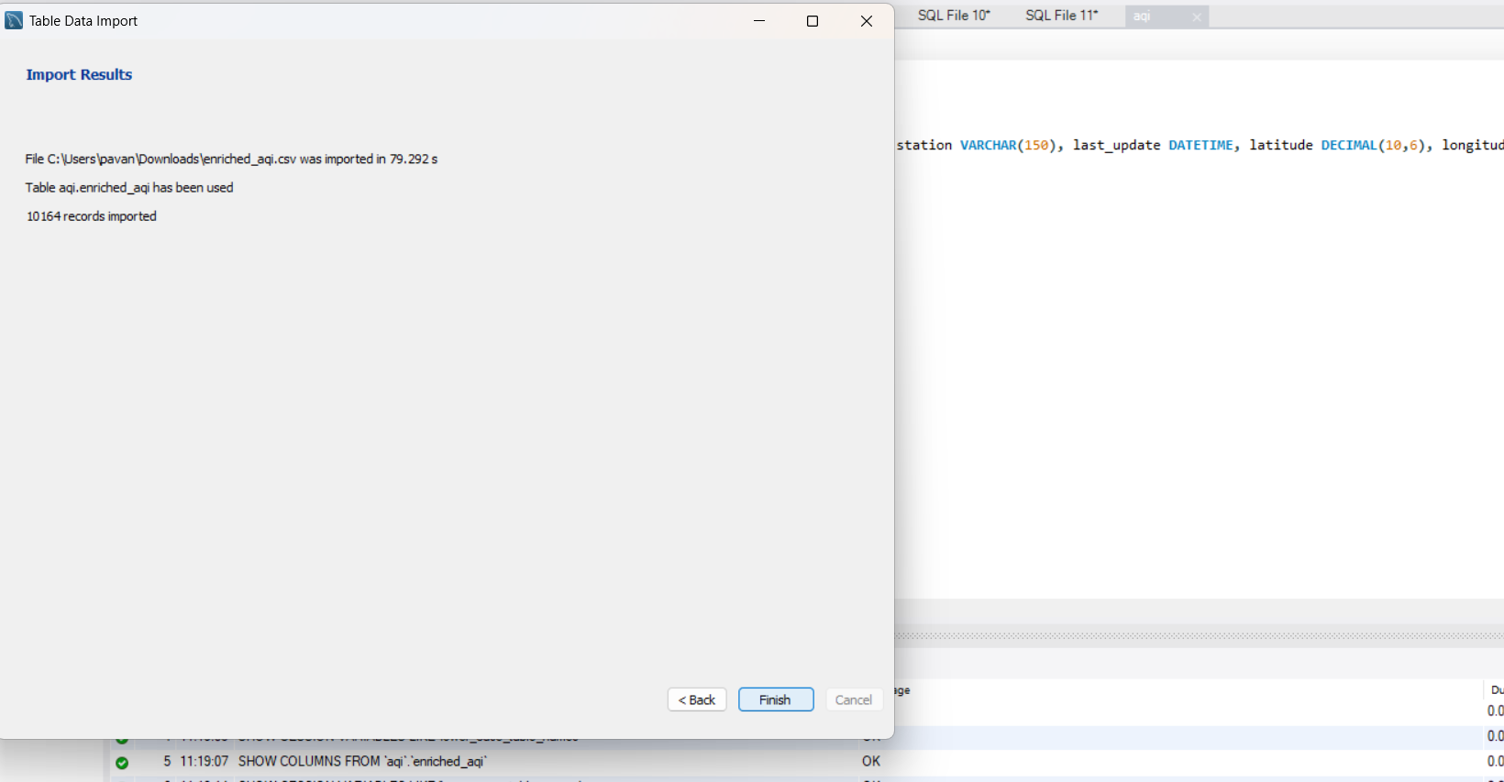
Explanation video : Dataloading.mp4
(Note: Creating Table Structure is optional as we can directly load table to SQl database)

Activity 2 : Perform SQL Operations
In this activity, we will use SQL to retrieve, filter, sort, group, and summarize the AQI data. We will apply SQL operations to analyze data, helping us identify important patterns and trends in the dataset.

1. Count Total Records
SELECT COUNT(*) FROM enriched_aqi;

2. Identify Missing AQI and Pollutant Values
SELECT * FROM enriched_aqi
WHERE pollutant_avg IS NULL
OR AQI IS NULL;

3. Null/missing-value
SELECT * FROM enriched_aqi
WHERE pollutant_avg IS NULL OR AQI IS NULL;

4. Min/Max AQI
SELECT MAX(AQI) AS max_aqi, MIN(AQI) AS min_aqi
FROM enriched_aqi;

5.City-level average AQI
SELECT city, ROUND(AVG(aqi),2) AS avg_aqi
FROM enriched_aqi
GROUP BY city
ORDER BY avg_aqi DESC;

6.Seasonal AQI comparison
SELECT Season, AVG(AQI)
FROM enriched_aqi
GROUP BY Season;

7.Pollutant-level severity check
SELECT pollutant_id, AVG(pollutant_avg), MAX(pollutant_max)
FROM enriched_aqi
GROUP BY pollutant_id
ORDER BY AVG(pollutant_avg) DESC;

8.City/station hotspot check
SELECT city, station, AVG(AQI) AS avg_aqi
FROM enriched_aqi
GROUP BY city, station
ORDER BY avg_aqi DESC
LIMIT 5;

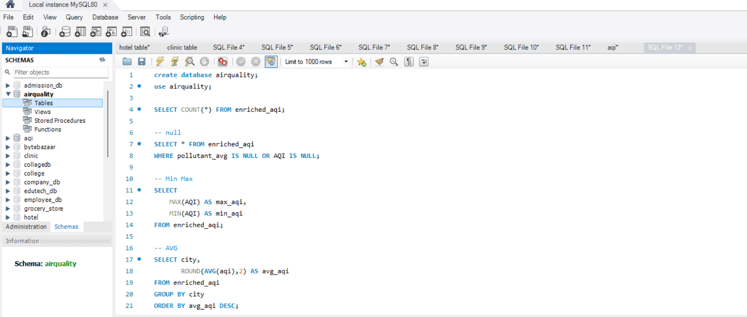
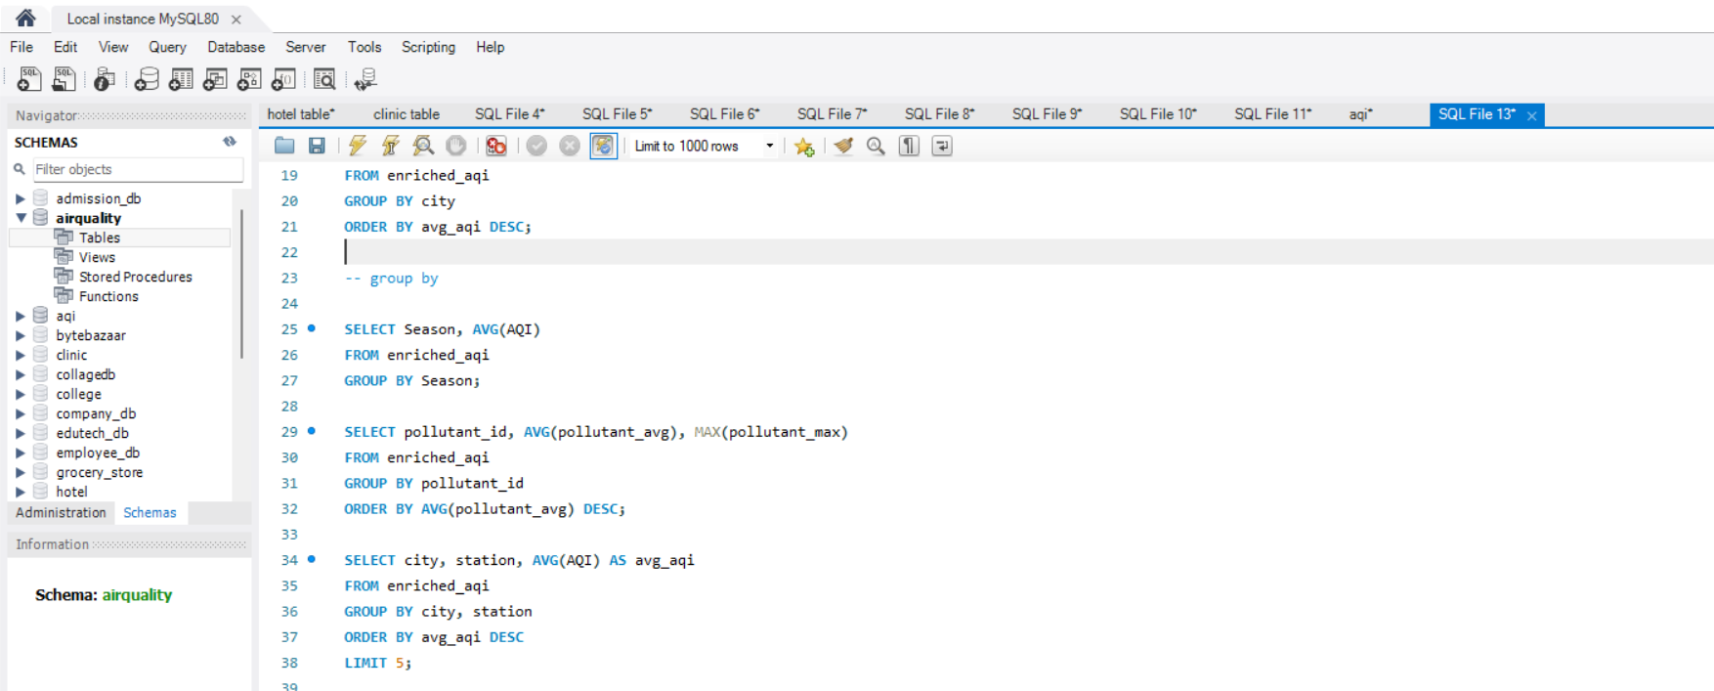

Milestone 3: Power BI Data Preparation
In this milestone, learners prepare and transform data in Power BI using Power Query. Learners will import data from different sources, clean and organize datasets, handle missing or inconsistent values, and apply transformations to make data analysis-ready. This milestone builds the foundation for creating accurate and reliable Power BI reports.

Activity 1 : Connect the SQL Database with Power BI
Power BI Desktop was connected directly to the SQL database using the built-in SQL Server connector, allowing the aqi_readings table to be imported for interactive visualization. This connection ensures that any refresh of the underlying database is reflected in the dashboards, maintaining data currency.
database to powerbi.mp4

Activity 2 : Clean the Data Using Power Query
- Removed records with missing or null AQI, pollutant_avg or station values.
- Standardized station names and trimmed whitespace/formatting inconsistencies across city and state text fields.
- Validated and converted Temperature_C, Humidity_%, Wind_Speed_kmh and pollutant fields to correct numeric types.
- Confirmed Year, Month, Day, Hour, Day_of_Week and Season derive correctly from last_update, and set Season and AQI_Bucket as sorted categorical fields.
- Removed duplicate station-reading combinations to prevent double-counting in aggregations.

Explanation video : power query.mp4

Milestone 4: Data Analysis & AI-Assisted Insights
In this milestone, learners work on analyzing data to identify patterns, trends, and meaningful insights with the support of AI-powered tools (Decomposition Tree, Key Influencers and Q&A ). Learners will explore data, interpret findings, and use AI assistance to enhance analysis and generate actionable insights. This milestone helps learners turn data into clear, business-focused conclusions.
Activity 1: KPI Creation and Explore Factors Affecting KPIs
A total unique visualization type was created using Power BI to analyze air quality performance across India. These include KPI cards, line charts, horizontal bar charts, a donut chart, a pie chart, and an AI-powered Decomposition Tree — all combined across an interactive dashboard and two report pages to explore the factors influencing AQI severity, seasonal pollution patterns, and station-level risk.

10,164  Records Loaded into MySQL | 30  States Covered | 268  Cities Monitored
503  Monitoring Stations | 118.24  Average AQI | 499  Maximum AQI Recorded

- 10,164 readings across 503 stations in 268 cities and 30 states — broad, high-resolution national coverage rather than a few concentrated hotspots.
- Average AQI of 118.24 falls in the "Unhealthy for Sensitive Groups" band, meaning even typical conditions pose a health risk for children, the elderly, and those with respiratory issues — not just an occasional bad day.
- Peak AQI of 499 is essentially at the top of the scale ("Hazardous"), indicating at least one station/time recorded conditions dangerous for the entire population, not just sensitive groups.
- The large gap between average (118) and max (499) shows pollution severity is highly uneven across locations — some stations are dramatically worse than the norm, suggesting localized hotspots rather than uniform moderate pollution.

Activity 2: Creating Visualization

In this activity, we will create different data visualizations in Power BI to represent the data clearly and uncover meaningful insights. We will select appropriate chart types based on the data and analysis requirements, configure relevant fields and measures, and customize titles, labels, legends, and other formatting options. We will then analyze the visualizations to identify trends, comparisons, patterns, and relationships within the data.

Activity 2.1: Decomposition Tree
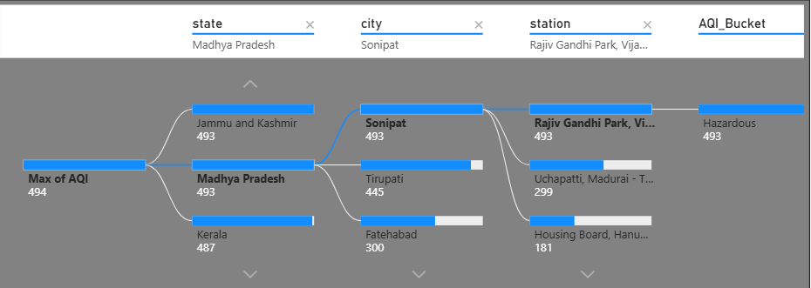
The AI-powered Decomposition Tree breaks down Max of AQI by city, revealing that Chamarajanagar, Khora and Vijayapura all share the dataset's peak AQI value of 494, with Nanded and Sonipat close behind at 493, and Aizawl and Vrindavan at 490. This shows the most extreme pollution spikes are spread across several mid-sized cities rather than concentrated in one national hotspot.
2.2: Key Influencer
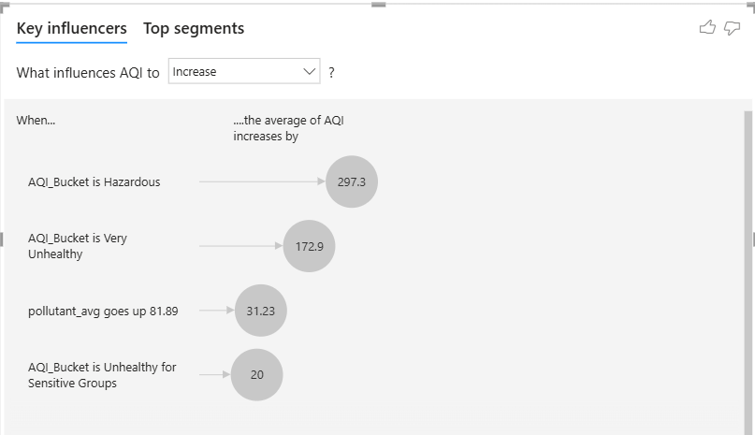
- AQI_Bucket classification is the dominant driver — when a reading falls into the "Hazardous" bucket, average AQI jumps by 297.3 points, and "Very Unhealthy" readings push it up by 172.9 points, confirming the bucket labels are strongly (and expectedly) tied to the underlying AQI value rather than being independent factors.
- Pollutant concentration has a real, standalone effect — a rise of 81.89 in pollutant_avg alone increases AQI by 31.23 points, showing that raw pollutant levels (not just the categorical bucket) are a meaningful quantitative driver worth tracking directly.
- Even the "milder" unhealthy bucket adds significant impact — "Unhealthy for Sensitive Groups" still contributes a 20-point increase, reinforcing that AQI severity escalates in fairly large steps between bucket tiers rather than gradually.
- The influencer list is dominated by AQI_Bucket itself, which is somewhat circular since AQI_Bucket is derived from AQI — for deeper causal insight, it would help to rerun this analysis excluding AQI_Bucket and focus on independent variables like pollutant_id, state, season, or weather (temperature, humidity, wind speed) to see what's really driving pollution up.

2.3.Visualization Analysis & Insights:
- Average of AQI by Season and State
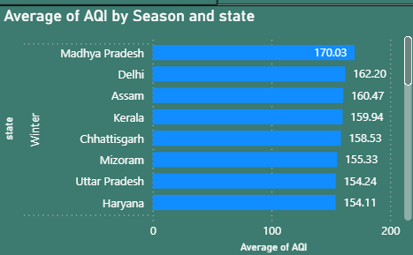
- Madhya Pradesh leads at 170.03, followed by Delhi (162.20) and Assam (160.47) — a mix of central, northern, and northeastern states, showing pollution severity isn't confined to one region of India.
- The gap between the top state (170) and 7th-ranked Haryana (154) is fairly narrow (~16 points), meaning the "worst" states form a tight cluster rather than one extreme outlier.

- Sum of AQI by AQI_Bucket
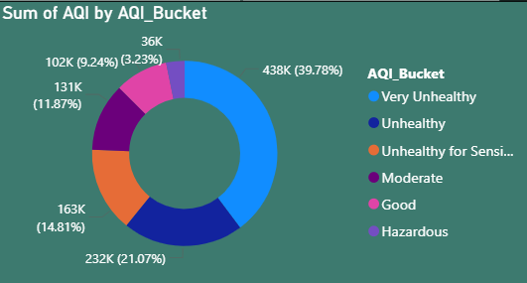

- Very Unhealthy dominates at 39.78% (438K), nearly 4x the "Good" share (9.24%) — the overall pollution burden is concentrated in the worst categories.
- Hazardous is the smallest at 3.23% (36K) — extreme events are rare but, as seen elsewhere, still reach AQI values near 500 when they occur.

- Count of Station by Season
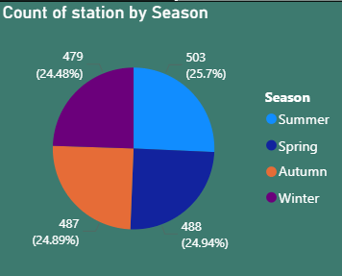
- Nearly even split (24.5%–25.7% per season) — this is a data-quality strength, since seasonal AQI comparisons elsewhere in the dashboard aren't distorted by unbalanced sampling.
4.Average of AQI by Year
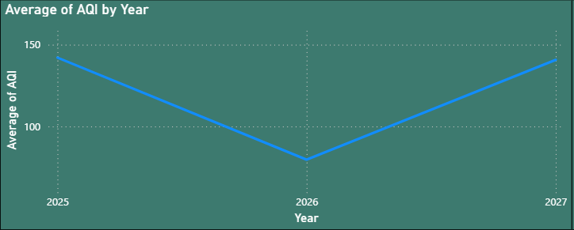
- Clear V-shape: ~150 (2025) → ~103 (2026) → ~152 (2027) — the 2026 dip is the standout anomaly here; worth confirming whether it's a real air-quality improvement or a partial/incomplete year of data.
5. Min of Wind_Speed_kmh by station
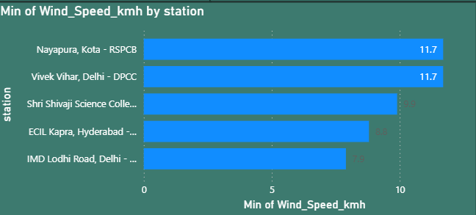
- Nayapura Kota and Vivek Vihar Delhi share the lowest minimum wind speed (11.7 km/h) — low wind at these stations may mean pollutants disperse less efficiently, compounding their AQI readings.
6. Average of AQI by city
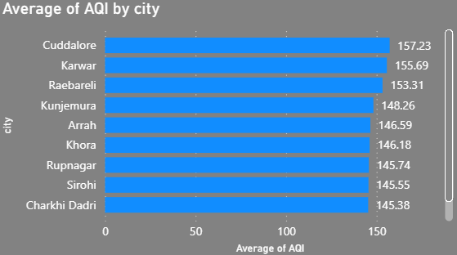
- Cuddalore (157.23) tops the list, followed by Karwar and Raebareli — none of these are major metros, indicating pollution hotspots exist in mid-sized/smaller cities, possibly tied to industrial or local sources rather than just urban density.

7.Average of AQI by Month
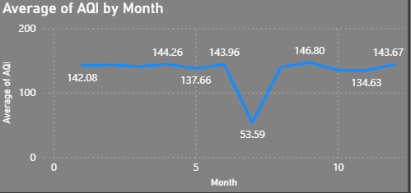
- Relatively flat and elevated most of the year (134–147) except for a sharp crash to 53.59 in one month — this isolated dip strongly suggests a data anomaly or gap rather than a genuine seasonal effect, since no natural weather pattern would cause such a sudden 60%+ drop.
8. Max of AQI by station
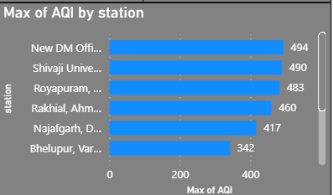
- New DM Office leads at 494 (essentially Hazardous ceiling), with Shivaji University (490) and Royapuram (483) close behind — these three stations warrant direct investigation as the most extreme pollution events in the dataset.
9. Average of AQI by pollutant id
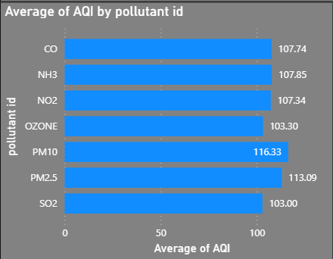
- PM10 (116.33) and PM2.5 (113.09) are clearly the highest-impact pollutants, ahead of gaseous pollutants like SO2 (103.00) and OZONE (103.30) — particulate matter is the primary concern, not gaseous pollution.
10 .Average of AQI by Hour
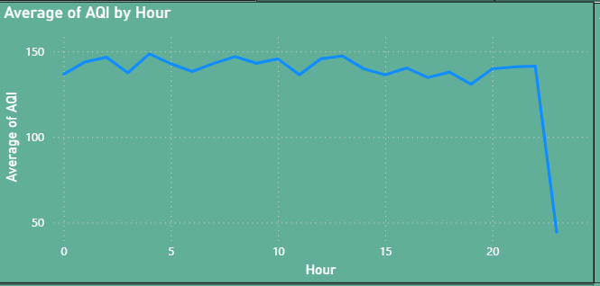
- AQI holds steady around 140 for hours 0–22, then crashes toward hour 23 — this cliff-edge drop late at night is too abrupt to be a natural pollution pattern and more likely reflects sparse or missing data in that hour.
11.Average of AQI by Day of Week
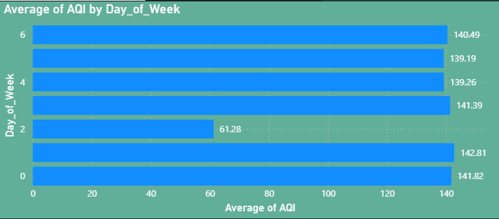
- Six of seven days cluster tightly at 139–142, but one day drops to 61.28 — this isolated anomaly (like the April dip and hour-23 dip elsewhere) reinforces a pattern of data gaps rather than a genuine weekly cycle in pollution.
12. Average of AQI by state
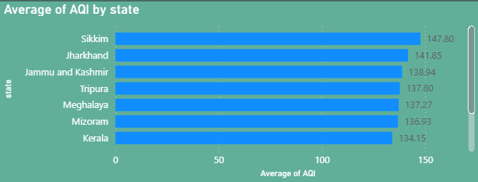
- Sikkim (147.80) and Jharkhand (141.85) top this list — notably different from Report 1's top states (Madhya Pradesh, Delhi), which suggests this page may be using a different filter, time slice, or the "top" list here just reflects a narrower band of states than Report 1's broader seasonal view.

Milestone 5: Data Visualization & Dashboard Development
In this milestone, learners work on transforming analyzed data into clear and interactive visualizations and dashboards. Learners will select appropriate charts, design effective dashboard layouts, apply filters and interactions, and present key findings in an easy-to-understand format. This milestone helps turn data into meaningful visual insights for better business understanding and decision-making.
Activity 1: Design of Interactive Dashboard
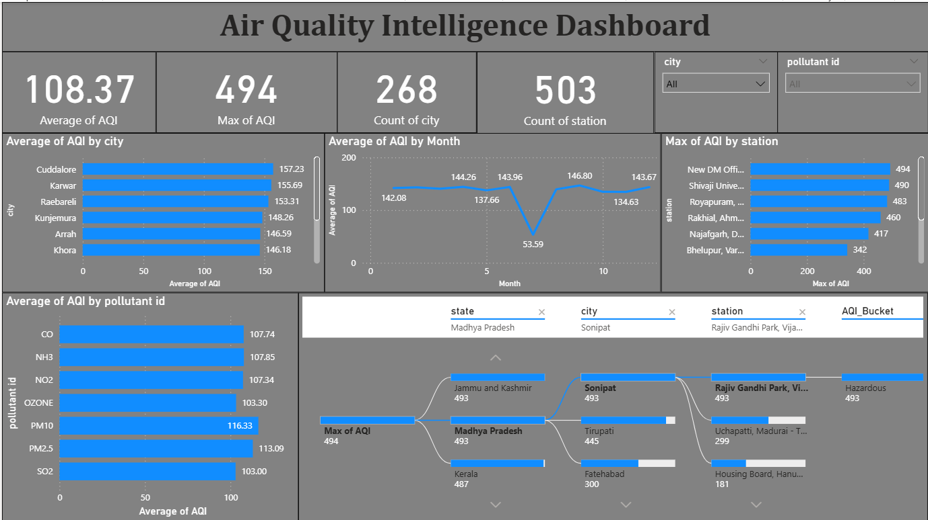

Insights:

- City-level hotspots aren't major metros: Cuddalore (157.23), Karwar (155.69), and Raebareli (153.31) top the city ranking — these are mid-sized/industrial cities, not the usual big-city suspects, suggesting localized sources (industry, geography) rather than sheer population density drive the worst averages.
- A sharp, isolated crash in month 5 (53.59 vs. ~140–147 in surrounding months) stands out as a clear anomaly. This drop is too abrupt to reflect a natural seasonal trend and more likely points to a data gap or incomplete reporting for that month — worth validating before drawing conclusions about a "good month."
- Extreme stations cluster tightly near the ceiling: New DM Office (494), Shivaji University (490), and Royapuram (483) are all within ~11 points of each other at the very top, while the drop to Rakhial Ahmedabad (460) and further down to Bhelupur Varanasi (342) shows a meaningful gap — these top 3 stations are the clearest candidates for targeted investigation.
- Particulate matter dominates pollutant impact: PM10 (116.33) and PM2.5 (113.09) are the highest-averaging pollutants, notably above gaseous pollutants like SO2 (103.00) and OZONE (103.30) — reinforcing that particulate control (dust, combustion particles) matters more here than gas-phase pollution.

Explanation video : Dashboard.mp4

Milestone 6: Report Development
In this milestone, a detailed, structured account of the analysis for decision-makers, analysts and stakeholders who need a fuller understanding of the data than a single dashboard page can offer. Two report pages were developed, each adding meteorological and time-based context beyond the primary dashboard.

Report 1: Air Pollution Monitoring & Analysis Report
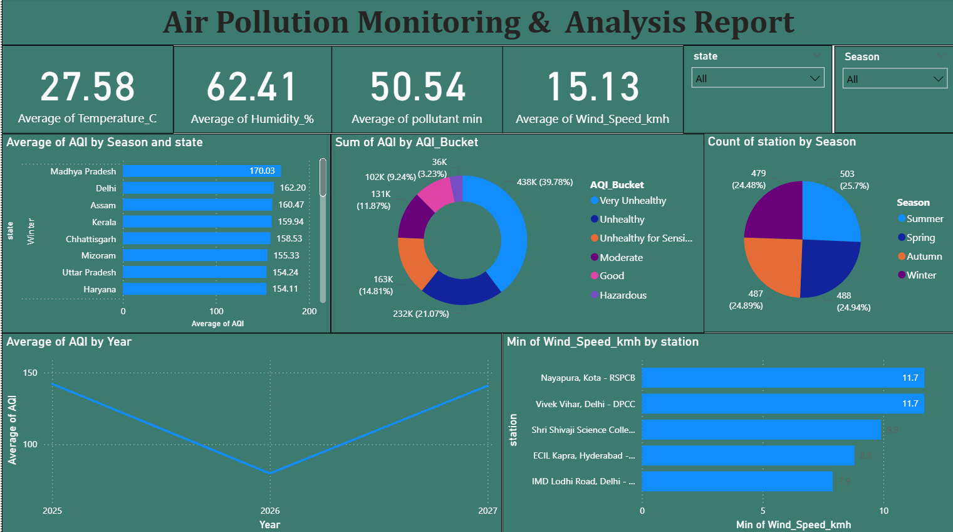

Explanation video : Report 1.mp4
Count of Station by Season — Balanced Year-Round Coverage. Monitoring activity is evenly split across seasons: Summer accounts for 503 station-readings (25.7%), Winter 488 (24.94%), Autumn 487 (24.89%) and Spring 479 (24.48%), confirming that the seasonal AQI comparisons in this project rest on a balanced sampling base rather than a season-skewed dataset.
Average of AQI by Year — A Dip Around 2026. The year-over-year trend shows average AQI declining toward 2026 before beginning to climb again in the surrounding years, suggesting either a temporary improvement in conditions or a partial-year data effect that merits monitoring as more readings accumulate.
Min of Wind_Speed_kmh by Station — Calm-Air Stations Flagged. Nayapura (Kota) and Vivek Vihar (Delhi) record the lowest minimum wind speeds in the network at 11.7 km/h, followed by Shri Shivaji Science College (9.9 km/h), ECIL Kapra (Hyderabad, 8.8 km/h) and IMD Lodhi Road (Delhi, 7.9 km/h). Because low wind speed limits pollutant dispersion, these stations are natural candidates for closer monitoring during high-pollution periods.

Report 2: Air Quality Patterns & Risk Analysis Report
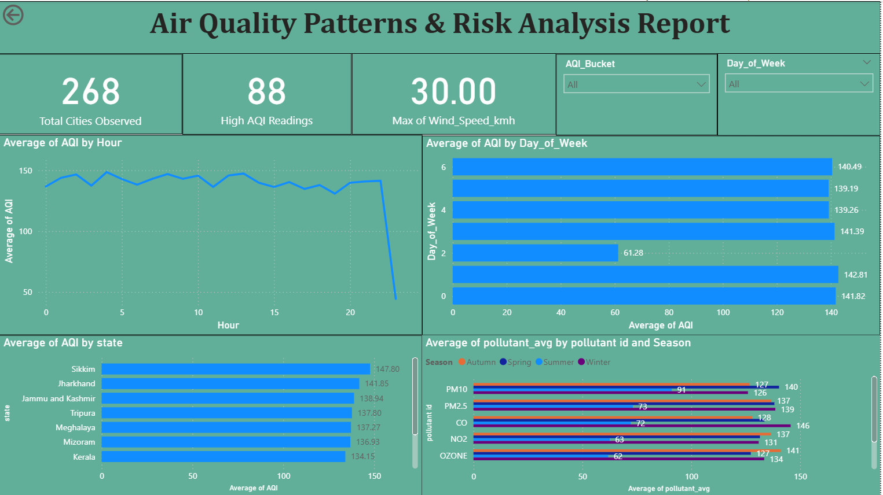

Explanation video : Report 2.mp4
Average of AQI by Day of Week — One Anomalous Weekday. AQI is consistently high across most days of the week (roughly 139-143), with one notable exception where average AQI falls to 61.28 — a pattern worth further investigation, as it may reflect a data-collection gap or a genuine one-day environmental event (such as a rain event or a public holiday reducing vehicular and industrial emissions).
Average of AQI by State — North-Eastern and Eastern States Lead. Sikkim records the highest average AQI among this view at 147.80, followed by Jharkhand (141.85), Jammu and Kashmir (138.94), Tripura (137.80), Meghalaya (137.27), Mizoram (136.93) and Kerala (134.15) — highlighting that hill and north-eastern states, often assumed to have cleaner air, also register consistently elevated AQI levels in this dataset.
Average of Pollutant_avg by Pollutant ID and Season. PM10 and PM2.5 show the highest average concentrations across all four seasons, with visible seasonal swings for CO, NO2 and OZONE. This view confirms — at a seasonal, pollutant-specific level — the same particulate-matter dominance identified in the main dashboard, while adding the seasonal lens needed for time-targeted public-health advisories.

Milestone 7: Performance Testing
In this milestone, Performance testing assesses the volume of data rendered from the database, the impact of data filters on responsiveness, and the complexity introduced by the number of visualizations and calculation fields, ensuring the dashboard and reports operate efficiently.

Activity 1 : Amount of Data Rendered to DB
The project loads the Enriched AQI dataset through a Power BI connection to the SQL database. The dataset contains 10,521 records across 22 fields spanning 268 cities and 503 monitoring stations. All records were imported without truncation, and the completeness of the load was verified using the Count of city (268) and Count of station (503) KPI cards on the dashboard.
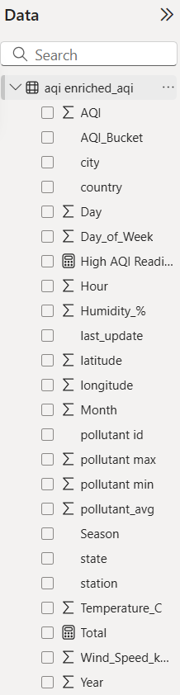

Activity 2 : Utilization of Data Filters
Six slicers are used across the dashboard and report pages — city and pollutant id (dashboard), state and Season (Report 1), and AQI_Bucket and Day_of_Week (Report 2) — allowing users to progressively narrow the analysis from a national view down to a single city, pollutant, season or day of the week, with every KPI and chart recalculating instantly on selection.
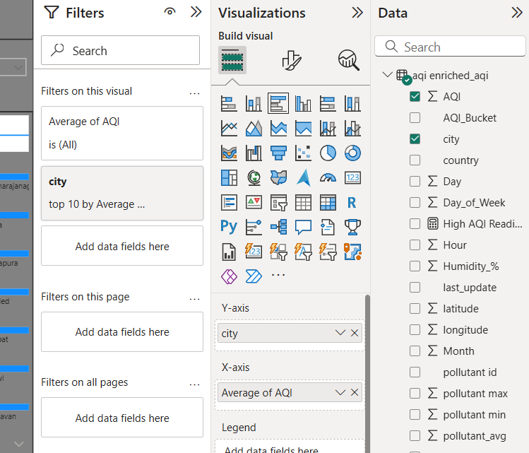

Activity 3 : Number of Calculation Fields
DAX measures were created beyond the base columns, including: Average of AQI, Max of AQI, Min of AQI, a High AQI Readings measure (counting readings in the Unhealthy-or-worse buckets), Total Cities Observed (distinct count of city), and a High AQI flag used to power the AQI_Bucket-based slicers and conditional formatting across the report pages.

Activity 4 : Number of Visualizations / Graphs
  - 1. Average of AQI by city
  - 2. Average of AQI by Month
  - 3. Average of AQI by pollutant id
  - 4. Max of AQI by station
  - 5. Decomposition Tree — Max of AQI by city (AI visual)
  - 6. Average of AQI by Season and state
  - 7. Sum of AQI by AQI_Bucket (donut)
  - 8. Count of station by Season (pie)
  - 9. Average of AQI by Year
  - 10. Min of Wind_Speed_kmh by station
  - 11. Average of AQI by Hour
  - 12. Average of AQI by Day_of_Week
  - 13. Average of AQI by state
  - 14. Average of pollutant_avg by pollutant id and Season

Milestone 8: Project Doc and Demo
In this milestone, we will finalize the project by documenting the complete analysis workflow, key findings, and outcomes. We will organize the project deliverables and conduct a final demo to showcase the implementation, explain the approach, and present the insights obtained from the AQI dataset.

Activity 1: End-to-End Explanation Video
Record a 5–7 minute screen-share video explaining the project end-to-end. Introduce your/team name, state the problem statement, highlight preprocessing steps, demonstrate dashboards, present findings, and showcase key insights clearly.

Activity 2: Project Documentation
Students have to write the project work step by step — starting from the problem, collecting data, cleaning it, making visuals/dashboards, finding results, and writing everything clearly in the document. Create the document as per the template provided.

